Question 1
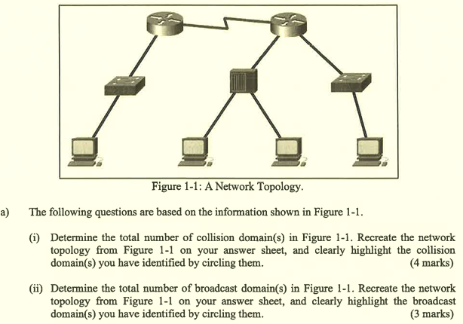
(i)
6 collision domains
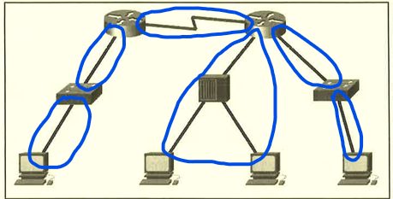

(ii)
4 broadcast domains
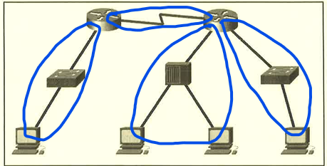

- Cut-through switching will immediately forward the frame after determining the destination MAC address of the frame and the egress port.
- The fragment-free method will check the destination and ensure that the frame has at least 64-byte size for eliminating runts.
- It does not check the FCS so the switch latency can be achieved within 10 microseconds.

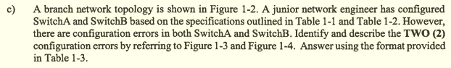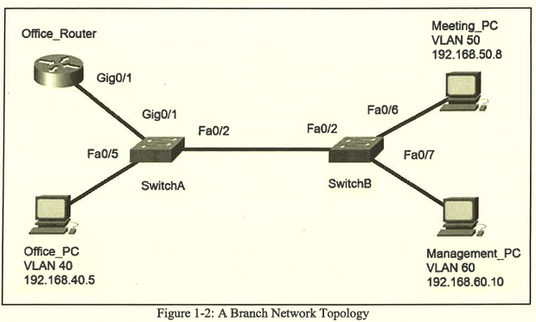
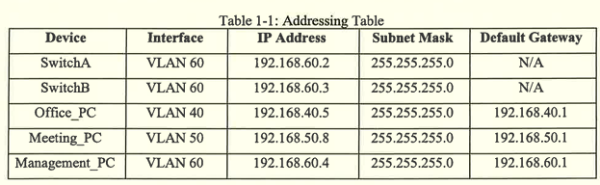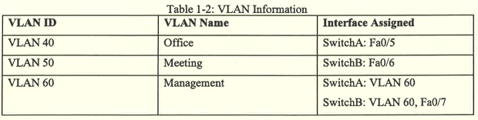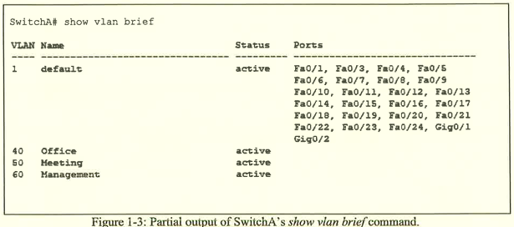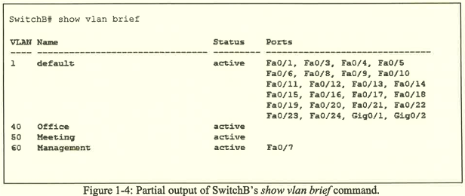
Device | Errors with Explanation | Proposed solution
Switch A | The interface Fa0/5 is wrongly assigned to VLAN 1 because the connected Office_PC is using VLAN 40. | The interface Fa0/5 should be assigned to VLAN 40 using command switchport access vlan 40.
Switch B | The interface Fa0/6 is wrongly assigned to VLAN 1 because the connected Meeting_PC is using VLAN 50. | The interface Fa0/6 should be assigned to VLAN 50 using command switchport access vlan 50.

Device | Configurations
Office_Router | en  conf t  interface Gig0/1.40  encapsulation dot1q 40  ip address 192.168.40.1 255.255.255.0  interface Gig0/1.50  encapsulation dot1q 50  ip address 192.168.50.1 255.255.255.0  interface Gig0/1.60  encapsulation dot1q 60  ip address 192.168.60.1 255.255.255.0  interface Gig0/1  no shutdown
SwitchA | en  conf t  vlan 40  name Office  vlan 50  name Meeting  vlan 60  name Management  interface Fa0/5  switchport mode access  switchport access vlan 40  no shutdown  interface vlan 60  ip address 192.168.60.2 255.255.255.0  switchport mode access  switchport access vlan 60  no shutdown

Question 2
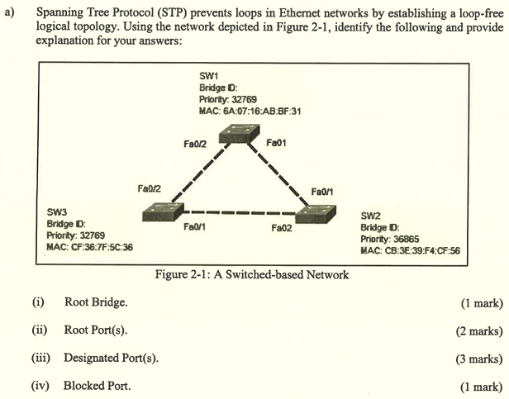
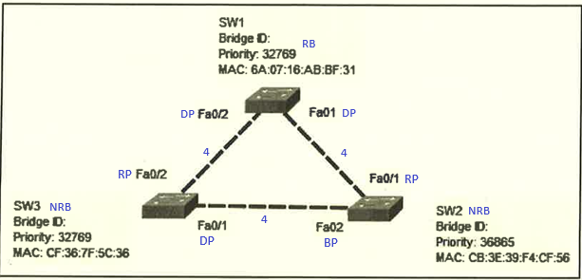
(i) SW1

(ii)
- SW2: Fa0/1
- SW3: Fa0/2

(iii)
- SW1: Fa0/1, Fa0/2
- SW3: Fa0/1

(iv) SW2 Fa0/2

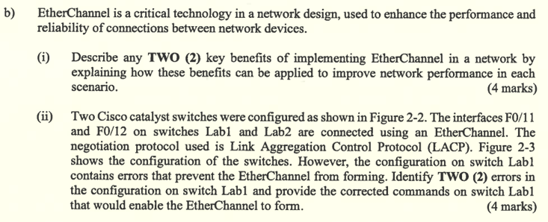
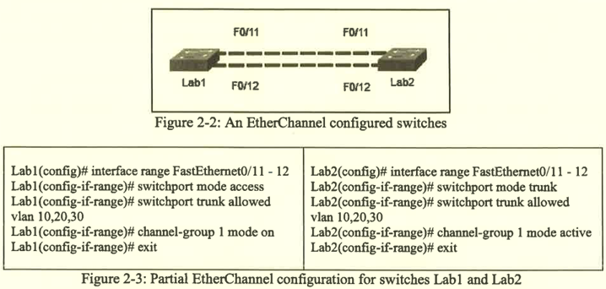
(i)
- EtherChannel can help ensure consistency when configuring multiple switch ports. The configuration tasks can be directly done on EtherChannel interface instead of individual port.
- EtherChannel can help Spanning-Tree Protocol (STP) to block the EtherChannel interface for preventing switching loops. When STP blocks one EtherChannel interface, all the interfaces associated with that EtherChannel link will be turned into inactive and vice versa because STP only sees logical links.

(ii)
- The switchport mode is configured wrongly in Lab1 switch.
  - The switchport mode should be in trunk mode instead of access mode.
  - The correct command is:
enable
config terminal
interface range FastEthernet0/11-12
switchport mode trunk

- The EtherChannel mode is configured wrongly in Lab1 switch.
  - The EtherChannel mode should be in active or passive mode.
  - The correct command is:
enable
config terminal
interface range FastEthernet0/11-12
no channel-group 1 mode on
channel-group 1 mode active

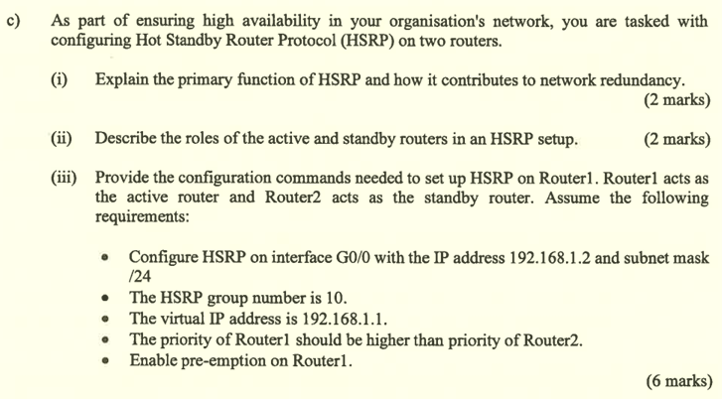
(i)
- HSRP can prevent the losing of network access if one of the routers has failed.
- It groups two routers into a HSRP group where one router with the higher priority becomes the active router, another with lower priority becomes the standby router.

(ii)
- In usual condition, the active routers will help for routing packets received.
- When the active router is failed or down, the standby router will take over to continue routing packets received.

(iii)

enable
config terminal
interface g0/0
ip address 192.168.1.2 255.255.255.0
No shut
standby 10 ip 192.168.1.1
standby 10 priority 180
standby 10 preempt

Question 3
- When a packet arrives at one of the router's interfaces, the router will search the routing table for a match.
- If the destination IP address is matched with the subnet of a directly connected interface, it will check ARP cache and forward to host on local subnet.
- Else, it will check whether the destination IP address is matched with the subnet of the remote network. If yes, it will encapsulate the frame and forward it out of the exit interface to the next loop.
- Else, it will check whether there is an available gateway of last resort. If yes, it will encapsulate the frame and forward it out of the exit interface to the next hop. If not, it will drop the packet and send an ICMP message back to the source IP address.

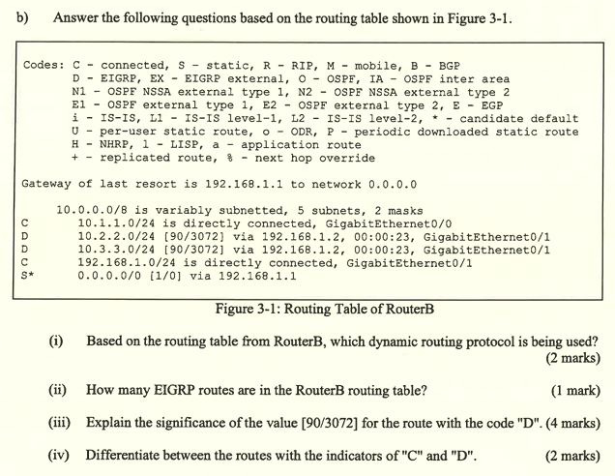
(i) Enhanced Interior Gateway Routing Protocol (EIGRP)

(ii) 2

(iii)
- The value 90 represents Administrative Distance which indicates the trustworthiness of the route. The lower the AD, the more trustworthy.
- The value 3072 represents the metric which is a measurable value that is assigned by EIGRP protocol to different routes based on bandwidth, delay, load and reliability.

(iv)
- The route with the indicators of "C" means that the network is directly connected to one of the router's interfaces.
- The route with the indicators of "D" means that the route was learned dynamically via EIGRP.

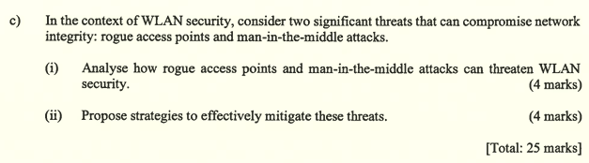
(i)
Rogue access points
- It is an access point or wireless router that has been connected to a corporate network without explicit authorization and against corporate policy.
- Once connected to this access point, an attacker can use it to capture MAC addresses, data packets and gain access to network resources from the connected devices.
- It can also allow an attacker to launch a man-in-the-middle attack.

Man-in-the-middle attacks
- This attack allows hackers to stay between two legitimate entities for reading or modifying the data passed between two parties.
- It may provide an opportunity for hackers to execute an "evil twin AP" attack where the attackers introduces a rogue AP and configures it with the same SSID as a legitimate AP.

(ii)
Rogue access points
- WLCs should be configured with rogue AP policies.
- Monitoring software should be implemented to actively monitor the radio spectrum for unauthorized APs.

Man-in-the-middle attack
- Legitimate devices should be identified on the WLAN.
- Users should be authenticated.
- Networks must be monitored from time to time for detecting abnormal devices or traffic.

Question 4
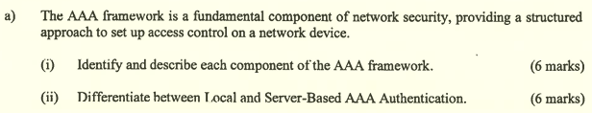
(i)
- Authentication checks whether the users are legitimate or permitted to access the network.
- It supports two ways for implementing AAA Authentication which are Local AAA Authentication and Server-Based AAA Authentication.

- Authorization governs what users can and cannot do on the network after they are authenticated.
- It uses a set of attributes that describes the user's access to the network. These attributes are used to determine privileges and restrictions for that user.

- Accounting collects and reports usage data used for auditing or billing purposes.
- The collected data includes the start and stop connection times, executed commands, number of packets and number of bytes.

(ii)
Local AAA Authentication
- It stores usernames and passwords locally in a network device.
- Thus, users can be authenticated against the local database.
- This method is ideal for small networks.

Server-Based AAA Authentication
- It allows routers accessing a central AAA server.
- AAA server contains the usernames and passwords for all users.
- Router uses Remote Authentication Dial-In User Service (RADIUS) or Terminal Access Controller Access Control System (TACACS+) protocols to communicate with AAA servers.
- When there are multiple routers and switches, this method is more appropriate.

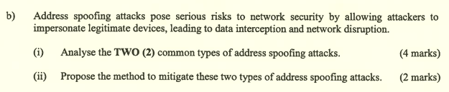
(i)
- MAC address spoofing attack
  - It occurs when a threat actor hijacks a valid IP address of another device on the subnet or uses a random IP address.
- IP address spoofing attack
  - It occurs when a threat actor alters the MAC address of their host to match another known MAC address of a target host.
  - The switch overwrites the current MAC table entry and assigns the MAC address to the new port. Then, it can inadvertently forwards frames destined for the target host to the attacking host.

(ii)
- IP Source Guard (IPSG) should be implemented to mitigate MAC and IP address spoofing attacks.

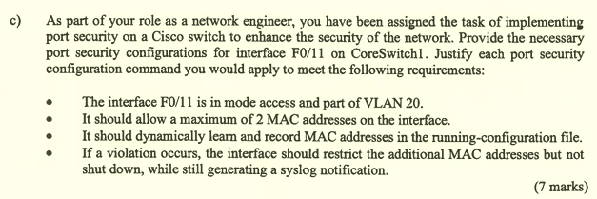
- interface f0/11
  - Select the specified interface for configuration later.
- switchport mode access
  - Configure the interface from dynamic auto into access mode.
- switchport access vlan 20
  - Assign the interface to VLAN 20.
- switchport port-security
  - Enable port-security for this interface.
- switchport port-security maximum 2
  - Limit the switchport to accept 2 MAC addresses at maximum only.
- switchport port-security mac-address sticky
  - Configure the switchport to dynamically learn and record MAC addresses in the running-configuration file.
- switchport port-security violation restrict
  - Configure the switchport to drop the packets with unknown source addresses, increments the security violation counter and generates a syslog messages without shutting down the port.

